


24 East Capitol Drive
Kapitolyo, Pasig City

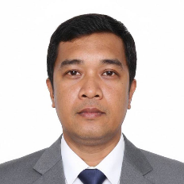
Valid until December 2026

Authorized by:
Jay-arh Alcantara

Erwin Anog
Cabling Installer

